1.25: The shape of the pile is not given, but gold coins stacked in a pile might well be in the shape of a pyramid, say with a height of 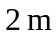 and a base 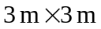. The volume of such a pile is 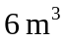, and the calculations of Example 1-4 indicate that the value of this volume is 